What type of activities do we do?

- Hold a Friday Night Family Night every week that includes a home cooked meal.

- Sponsor many youth activities to include a Halloween party, Christmas party and Easter party free of charge.

- Hold many dances throughout the year.

- Provide food baskets to “needy families” in our community three times a year.

- Participate in various Pro-Life activities to include an annual Candlelight Vigil and Kick-Off Rally.

- Help the Intellectually Disabled through the annual “Tootsie Roll” Program.

- Provide our widows with the opportunity to join our widows program where they participate in monthly luncheons and other activities.

- Offer members life insurance to include life insurance for handicapped children.

- Assist our parishes with various needs.

- Host a Red Cross Blood donor program.

- Loan medical equipment to those in need.

- Provide financial assistance to seminarians.

- Participate in the Keep Christ in Christmas program

- Rosary Program

- Sponsor Ladies Auxiliary

Some other facts

- The Knights of Columbus donate $150-$190 million annually to charitable causes.
- The Ukraine Solidarity Fund collected over $24M from 68,300 Donors to support humanitarian support in Ukraine
- The Maryland Knights of Columbus pledged $50,000 to aid in the restoration of the Basilica of the Assumption in Baltimore, America’s first Cathedral. The Supreme Council pledged $1M to support this restoration.
- Annually the Maryland Knights of Columbus raise over $315,000 to donate to the mentally and physically challenged.

Statistics (2023):
Total Membership Worldwide 2 Million
Total Councils Worldwide 17,000
Total Donations $190 Million
Total Volunteer Hours Donated 47.5 Million
Maryland Membership 25,500

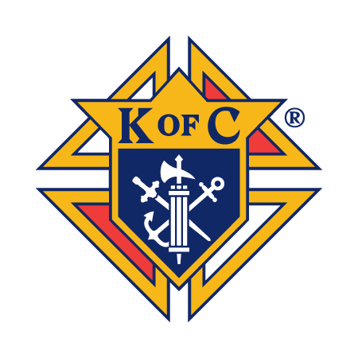

Today, more than ever, the world needs a few more Knights.
Why not join us?

For free dues for one year, join online at:
www.kofc.org/joinus

For information about joining
Father XXX Council contact:
Grand Knight XXXX @ name@gmail.com
Deputy Grand Knight XXXX @ name@domain.com
Financial Secretary XXXX @ xxxx@domain.com

THESE MEN THEY CALL KNIGHTS

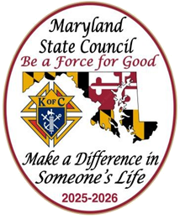
Knights of Columbus

XXXX XXXX Council
No. 1234
Address 1
City, MD Zip Code

What is the Knights of Columbus?

The Knights of Columbus is a dynamic Catholic, family, fraternal organization of Catholic men who join together in family, charitable, fraternal, community and youth activities. The over 2.0-million-member organization is international in character; however, the major emphasis is focused on the activities of our local parish and community. A major thrust of our activities is directed at involving the member’s entire family.

Who is eligible for Membership?

Any man who is a practical Catholic, 18 years of age or older, may apply for membership in the Knights of Columbus. A practical Catholic is one who regularly practices his faith by going to Mass on Sunday, receiving the Sacraments, etc.

What is required of members?

Each member must be a practical Catholic and is required to pay annual dues, which can be paid either annually or quarterly. A new member must also pay a one-time initiation fee. A new member can join online at www.kofc.org/join. The member must participate in a ceremony called exemplification to join the local council. The Exemplification will allow him to understand better, the principles of the Order (charity, unity, fraternity and patriotism) and how we, as Knights of Columbus, are expected to conduct ourselves.

Men who join the Knights of Columbus participate in council and State level programs, Pray with Brother Knights, attend meetings, participate in Council activities, serve on committees, or serve as an officer as their time permits and their interests dictate.

The rewards and satisfaction of membership in the Knights of Columbus are proportional to participation of each member and his family.

Why should you join the K of C?

Many brother Knights say that they joined to be a more effective Catholic; to be associated with and meet other Catholic men and their families; to make new friends; to strengthen their ties with the Catholic faith; to expand their community and social activities; to help others in a meaningful and organized way and thus achieve a truly unique sense of accomplishment.

As Catholics, we have an obligation to share our Faith, assist the less fortunate of our community, and support our parishes.

Many find that, as individuals, it is sometimes difficult to be involved in a significant way and balance the time constraints in our personal lives. As a Knight you and your family can share in the tremendous works of the Order without feeling the need to identify projects and organize your support all by yourself. In this way, your whole family can fulfill their obligations and feel satisfied that they are a part of more satisfying and worthwhile activities then they could possibly undertake as an individual. There are a variety of good reasons to consider joining the Knight of Columbus.

Faith In Action

Each Council operates within four major program areas: Faith, Family, Community, and Life.

How often does our Council meet?

There are two meetings held each month; the first and third Tuesday of the month. The first meeting is a business meeting and the second is a social meeting. The meetings normally last about one hour and usually involve interesting and lively discussion of key topics. Members are encouraged to take an active part in these discussions. Opinions and ideas are always welcomed. Meetings are followed by refreshments and other activities such
as guest speakers and films, or just friendly socializing with other members.

Father XXXX Council No. 12234

Fr. XXXX Council was founded in 1920. The Council home is currently located in historic at St. XXXX Church, City, Maryland.

Since its inception, the Council has grown into over 100 members. The primary parishes represented by our Brother Knights are: St. XXXX, Christ the King and St. XXXX.

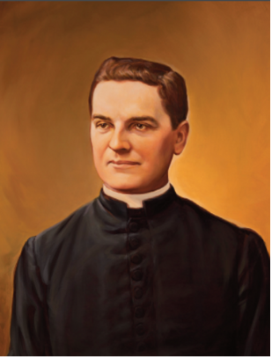

  kofc.org/Join |   kofc.org/unete

